Software Requirements Specification

For

Online Shopping System

Version 1.0

Prepared by Rajgauri Kishor Khemnar (15IT133)

National Institute of Technology Karnataka, Surathkal

January 9, 2018

Table of Contents

Table of Contents ii

Revision History ii

1. Introduction 1

1.1 Purpose 1

1.2 Document Conventions 1

1.3 Intended Audience and Reading Suggestions 2

1.4 Product Scope 2

1.5 References 2

1.6 Overview 2

2. Overall Description 3

2.1 Product Perspective 3

2.2 Product Functions 3

2.3 User Classes and Characteristics 3

2.4 Operating Environment 4

2.5 Design and Implementation Constraints 4

2.6 User Documentation 4

2.7 Assumptions and Dependencies 4

3. External Interface Requirements 5

3.1 User Interfaces 5

3.2 Hardware Interfaces 5

3.3 Software Interfaces 5

3.4 Communications Interfaces 5

4. System Features 6

4.1 Administrator login 6

4.2 Administrator logout 6

4.3 Administrator adds products 7

4.4 Administrator deletes products 7

4.5 Customer registers into system 8

4.6 Customer logs into system 9

4.7 Customer logs out of system 9

4.8 Customer searches for product 10

4.9 Customer adds item to cart 10

4.10 Customer removes item from cart 11

4.11 Customer confirms order 11

5. Other Nonfunctional Requirements 12

5.1 Performance Requirements 12

5.2 Safety Requirements 12

5.3 Security Requirements 12

5.4 Software Quality Attributes 12

5.5 Business Rules 13

6. Other Requirements 13

Appendix A: Glossary 13

Appendix B: Analysis Models 13

Appendix C: To Be Deterimined List 13

Revision History

|  |  |  |  |
| --- | --- | --- | --- |
| **Name** | **Date** | **Reason For Changes** | **Version** |
|  |  |  |  |
|  |  |  |  |

# Introduction

## Purpose

The purpose of the document is to collect and analyze all assorted ideas that have come up to define the system, its requirements with respect to consumers. In short, the purpose of this SRS document is to provide a detailed overview of the software product, its parameters and goals. This document describes the project's target audience and its user interface, hardware and software requirements. It defines how our client, team and audience see the product and its functionality.

## Document Conventions

Inventory – Merchandise that is purchased and/or produced and stored for eventual sale

Ethernet – a family of frame – based computer-networking technologies for Local Area Net works.

MySQL – is a RDBMS based on SQL, which is used for adding, removing, and modifying information in the database.

RDBMS – Relational Database Management System

SQL – Structured Query Language

HTML – Hypertext Markup Language

PHP – Hypertext Preprocessor

XAMPP - A free and open source cross-platform web server solution stack package

CSS – Cascading Style Sheet

HTTP – Hypertext Transfer Protocol

## Intended Audience and Reading Suggestions

## This project is a prototype for the Online Shopping System and is restricted within college premises. This has been implemented under the guidance of college professors. This project is useful for customers looking for a virtual shopping experience and administrators looking for selling their products online.

## Project Scope

The Online Shopping System is designed to provide quality service to the customers and to allow new online store owners a quick and easy means to setup and perform sales and other core business over the internet. The system has to be designed with a database capable of maintaining inventory details up-to-date. All payments will be through cash during the delivery or shipping of items. It should be user friendly for computer illiterate, easy to maintain by administrators and only accessible by registered users.

## References

IEEE. *IEEE Std 830-1998 IEEE Recommended Practice for Software Requirements Specifications*

IEEE Computer Society, 1998.

## Overview

The remaining sections of this document provide a general description, including characteristics of the users of this project, the product's hardware, and the functional and data requirements of the product.

Section 2 gives an overall description of the software. It gives what level of proficiency is expected of the user, some general constraints while making the software and some assumptions and dependencies that are assumed.

Section 3 gives specific requirements, which the software is expected to deliver.

Section 4 states Functional requirements for various use cases.

Section 5 gives some performance requirements and design constraints.

# Overall Description

## Product Perspective

The product is a web-based system that allows the customer to shop virtually and allow customers to buy the items of their desire from the store. It is aimed towards the vendors who want to reach out to the maximum cross-section of customer and common people who can be potential customer. It should be user-friendly, ‘quick to learn’ and reliable application for the above purpose.

## Product Functions

Customer module - A customer should have a user account for carrying out transactions.

Administrator module - Administrator provides the customer with an account following proper  registration procedures to prevent malpractices in the transactions. It also provides the customer with a list of products to shop from.

* Account Management: Allows users to create, edit, and view accounts information. It also allows the user to log-in/out of the system.
* Search Engine: Tool that assists the user in finding a specific item in the database. It can receive search criteria, find search criteria, and return  the results of the search.
* Product Management: Allows administrator to manage the product line shown on the web site.
* Shopping Cart: Temporary storage for customers shopping on the web. Items from the inventory can be reserved in a virtual cart until the customer decides  to purchase them.
* Purchasing and Payment: Used to approve cash on delivery payment from buyers when purchasing items in the cart.

## User Classes and Characteristics

There are following types of users in the Online Shopping System.

**Administrators:** The administrators have complete control over all the activities that can be performed.

* -  They verify the user after he/she registers.
* -  They must provide rules for the transactions.
* -  They must maintain the website and update the same making necessary  changes at times.
* -  They must inform the users about their transaction status and keep them  updated about the progress through emails.
* -  Any failures in the system have to be detected and repaired.
* **Customers:** They are the registered members of the online store website. They can view the list of products and purchase items.

## Operating Environment

Operating environment for the Online Shopping System is as listed below

* Client/server system
* Operating system to be used: Windows/Linux/MacOS.
* Database: MySQL
* Platform: PHP

## Design and Implementation Constraints

The main constraint here is the checking the genuineness of the buyer, which is not always possible. There can be security risks involved.  Also, real-life credit card validation and Banking system are not implemented.

## User Documentation

* A README file providing instructions about the software will be provided along with project to help users use the functionalities with ease.
* A HELP tab will be provided on the website where an online user manual will be provided.

## Assumptions and Dependencies

We assume that the administrator is created in the system already.

# External Interface Requirements

## User Interfaces

The user interface shall be web-based, allowing users to remotely access the system via several applications. Users will be able to use the software through applications such as Microsoft Internet Explorer, Mozilla, et al. Each part of the user interface intends to be as user friendly as possible. The fonts and buttons used will be intended to be very fast and easy to load on web pages. The pages will be kept light in space so that it won’t take a long time for the page to load. The starting page will be a home page regarding the store and a number of buttons with the specific category of the products sold. The customer will be given an option to search a product or a category through the search tool provided in the website. In adding product to his/her cart, the customer will have to select the quantity of the product to be added and click on the “add to cart” button. While in removing the product, he/she will select the item in the cart, and specify quantity of items to be removed and clicks the button ‘Remove Item’. There will be buttons added for the managing of accounts of the customer and the administrator.

## Hardware Interfaces

Since the application must run over the Internet, all the hardware shall require to connect internet will be hardware interface for the system. For e.g. Modem, WAN – LAN, Ethernet Cross-Cable.

## Software Interfaces

During our system development, we have to create and design website interface functions and a database system, so it has a set of software requirements.

The following are the needed requirements:

Web browser, PHP, XAMPP application, MySQL Database server

## Communications Interfaces

The system shall use the HTTP and SMTP protocol for communication over the Internet.

# System Features

## Administrator login

### Description and priority

### Login to an administrator account with the system

### Priority: High

### Stimulus/Response Sequences

* Administrator loads login page
* Logs into account after credentials are verified from database
* Administrator is directed to home page

### Functional Requirements

1. Administrator clicks button or link to initiate login process.

2. System prompts the Administrator for username and password.

3. System verifies information.

4. System displays account home page to Administrator.

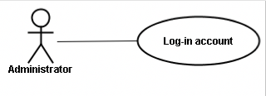

## Administrator logout

### Description and priority

* Logout the Administrator account on the system.

### Priority: High

### Stimulus/Response Sequences

* Administrator selects logout option
* Administrator directed to login page

### Functional Requirements

1. Administrator clicks button or link to initiate logout process.

2. System displays login page.

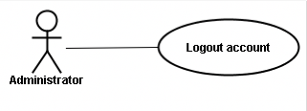

## Administrator adds product

### Description and priority

* Admin adds product to the system.

### Priority: Medium

### Stimulus/Response Sequences

* Administrator selects add product option
* Changes made in database upon addition of product

### Functional Requirements

1. Administrator clicks the button or link to initiate Add Product process.

2. System prompts the Administrator to fill out product details.

3. System displays the newly created product page.

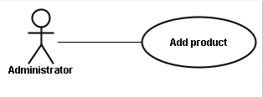

## Administrator deletes product

### Description and priority

* Admin deletes product from the system.
* Priority: Medium

### Stimulus/Response Sequences

* Administrator selects delete product option
* Changes made in database upon deletion of product

### Functional Requirements

1. Administrator clicks the button or link to initiate Remove Product process.
2. System prompts the Administrator to select a product from product list.
3. System removes the product information from the system.
4. System displays the newly created product page.

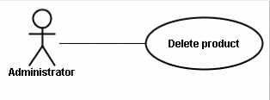

## Customer registers into system

### Description and priority

### Register a new customer account with the system.

### Priority: High

### Stimulus/Response Sequences

* Customer loads registration page
* Credentials of customer added to database upon verification
* Customer redirected to home page

### Functional Requirements

1. Customer first clicks on the button or link to initiate registration process.
2. System prompts the customer to fill out his/her first name, last name, billing address, shipping address, email address, and their password.
3. Customer enters fields.
4. System validates the customer's information.
5. System creates a new account for the Customer.
6. System displays an account home page to Customer.

* 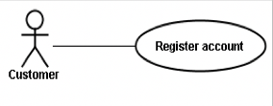

## Customer logs into system

### Description and priority

### Login to a customer account with the system.

### Priority: High

### Stimulus/Response Sequences

* Customer loads login page
* Credentials of customer verified from database
* Customer redirected to home page

### Functional Requirements

1. Customer clicks on the button or link to initiate the login process.
2. System prompts the customer for his/her username and password.
3. System verifies the information.
4. System displays account home page to the Customer.

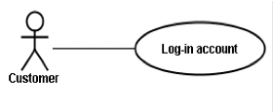

## Customer logs out of system

### Description and priority

### Logout a customer account from the system.

### Priority: High

### Stimulus/Response Sequences

* Customer clicks on the logout option
* Customer redirected to login page

### Functional Requirements

1. Customer clicks the button or link in order to initiate logout process.
2. System displays the login page.

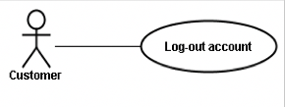

## Customer searches for products

### Description and priority

### Customer clicks on display products tab

### Priority: Medium

### Stimulus/Response Sequences

* Customer clicks on display products option
* Product list is displayed from database

### Functional Requirements

1. System displays all the products.
2. User scrolls through list to search for desired product.

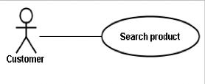

## Customer adds item to cart

### Description and priority

### Customer adds item(s) to virtual cart of its account

### Priority: Medium

### Stimulus/Response Sequences

* Customer clicks on add to cart option
* Product added to customer’s cart database

### Functional Requirements

1. Customer clicks on the “add to cart” button next to the desired item.
2. System adds the item(s) to the cart.
3. Customer confirms the items in the cart.
4. Customer returns to product listings.

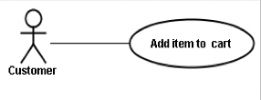

## Customer removes item from cart

### Description and priority

### Customer deletes product from virtual cart of account

### Priority: Medium

### Stimulus/Response Sequences

* Customer clicks on delete from cart option
* Product removed from customer’s cart database

### Functional Requirements

1. Customer selects the item in the cart and clicks the button to initiate the deletion of item(s).
2. System removes the item(s) from the cart.

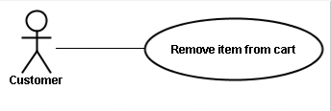

## Customer confirms order

### Description and priority

### Customer confirms purchase of products

### Priority: High

### Stimulus/Response Sequences

* Customer loads buy now option
* Customer asked to confirm list of products of purchase and delivery address.

### Functional Requirements

# Customer clicks the button or link to initiate the confirmation process.

# Customer confirms order.

# 

# Other Nonfunctional Requirements

## Performance Requirements

1. User will be sign in with in 20-30 seconds.
2. If anybody makes a new account then he/she will be registered within 30 seconds.
3. Search results shown within 15 sec.

## Safety Requirements

It should be ensured that the system is reliable in its operations at all times.

## Security Requirements

Security systems need database storage just like many other applications. However, the special requirements of the security market mean that vendors must choose their database partner carefully.

## Software Quality Attributes

* **AVAILABILITY:** The product should be made available as many customers are doing transactions.
* **CORRECTNESS:** The product details provided must be correct and credible.
* **MAINTAINABILITY:** The administrators must maintain the website from time to time.

## Business Rules

Only users with valid credentials for the software should be able to use the software. A typical customer should be granted default privileges only. A limited number of Administrative users should be created to manage data.

# Other Requirements

<< There aren’t any other requirements in version 1.0 as of now. >>

Appendix A: Glossary

|  |  |
| --- | --- |
| TERM | DESCRIPTION |
| Electronic commerce | Commonly known as e-commerce, ecommerce, or e-business, it consists of the buying and selling of products or services over electronic systems such as the Internet and other computer networks. |
| SRS | Software Requirement Specification |
| Administrator | Also known as Merchant; the people who add the product in the web store for the sale. They are an important part of the project. |
| Customer | It refers to the people who will purchase the things from the web store. |
| IEEE | Institute of Electrical and Electronics Engineers |

Appendix B: Analysis Mode

1. Use Case Diagram:

Macintosh HD:Users:rajgaurikhemnar:programs:software_engineering:Use Case Diagram for Online Shopping System (UML).pdf

2. Entity-Relationship Diagram:

Macintosh HD:Users:rajgaurikhemnar:programs:software_engineering:er diagram.pdf

3. Activity Diagram:Macintosh HD:Users:rajgaurikhemnar:programs:software_engineering:Activity Diagram.pdf

4. Swimlane Diagram: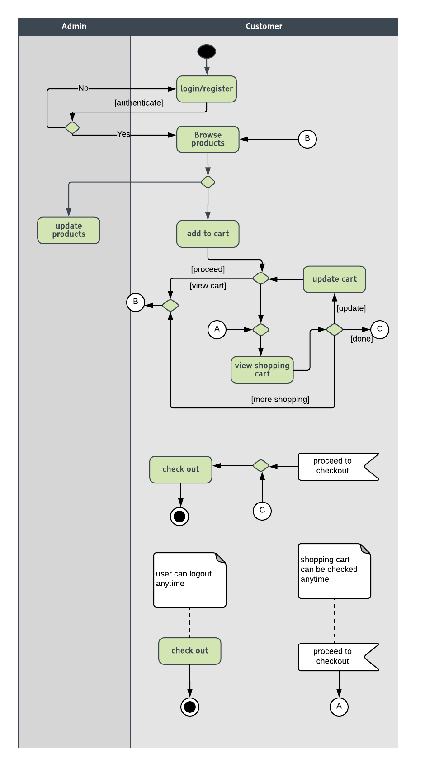

5. Navigation Diagram-Admin:

Macintosh HD:Users:rajgaurikhemnar:programs:software_engineering:navigation -admin.pdf

6. Navigation Diagram-Customer:

Macintosh HD:Users:rajgaurikhemnar:programs:software_engineering:navigation-customer.pdf

Appendix C: To Be Determined List

* User Interface of the project

Macintosh HD:Users:rajgaurikhemnar:programs:software_engineering:er diagram.pdf